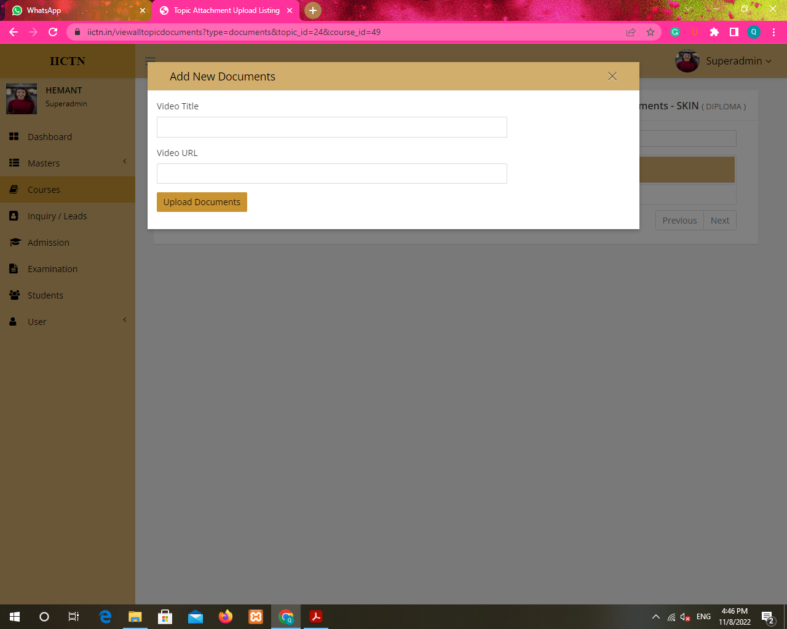

- Same title in both docs and video upload and no attachment options for notes in courses.

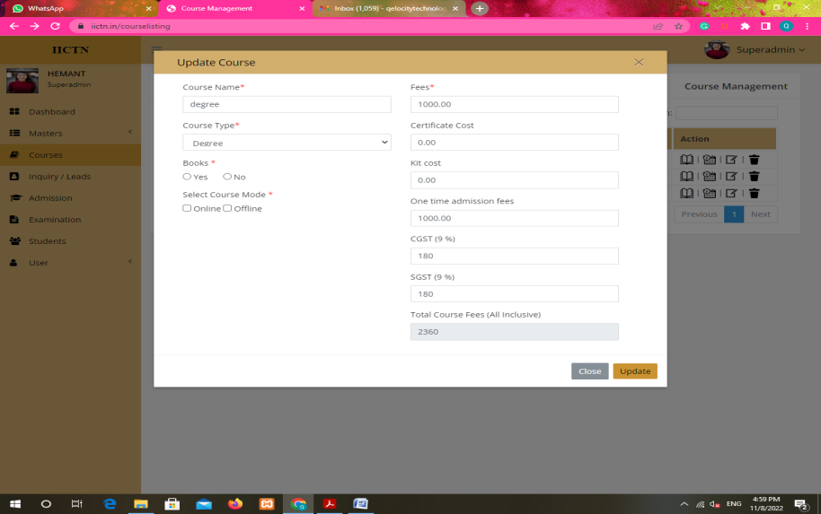

Books and courses online offline check box not working on edit.

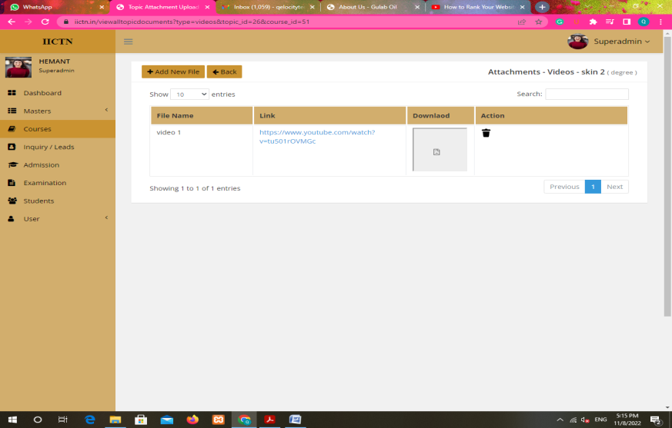

Remove download option from video as per Priyesh sir

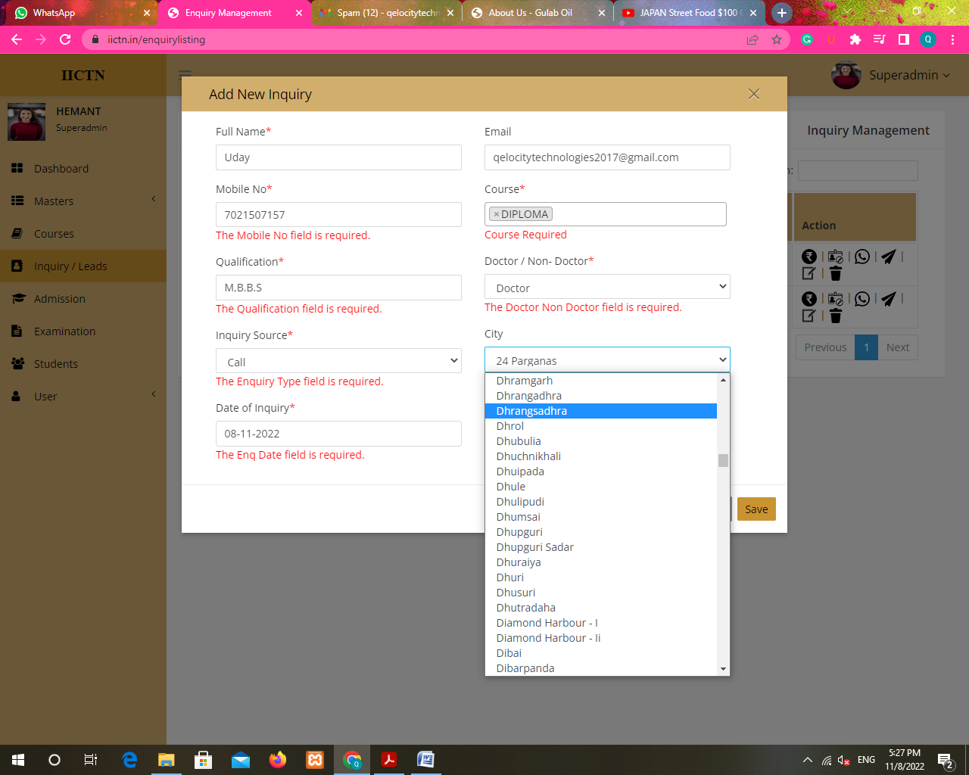

Give dropdown with search in complete software.

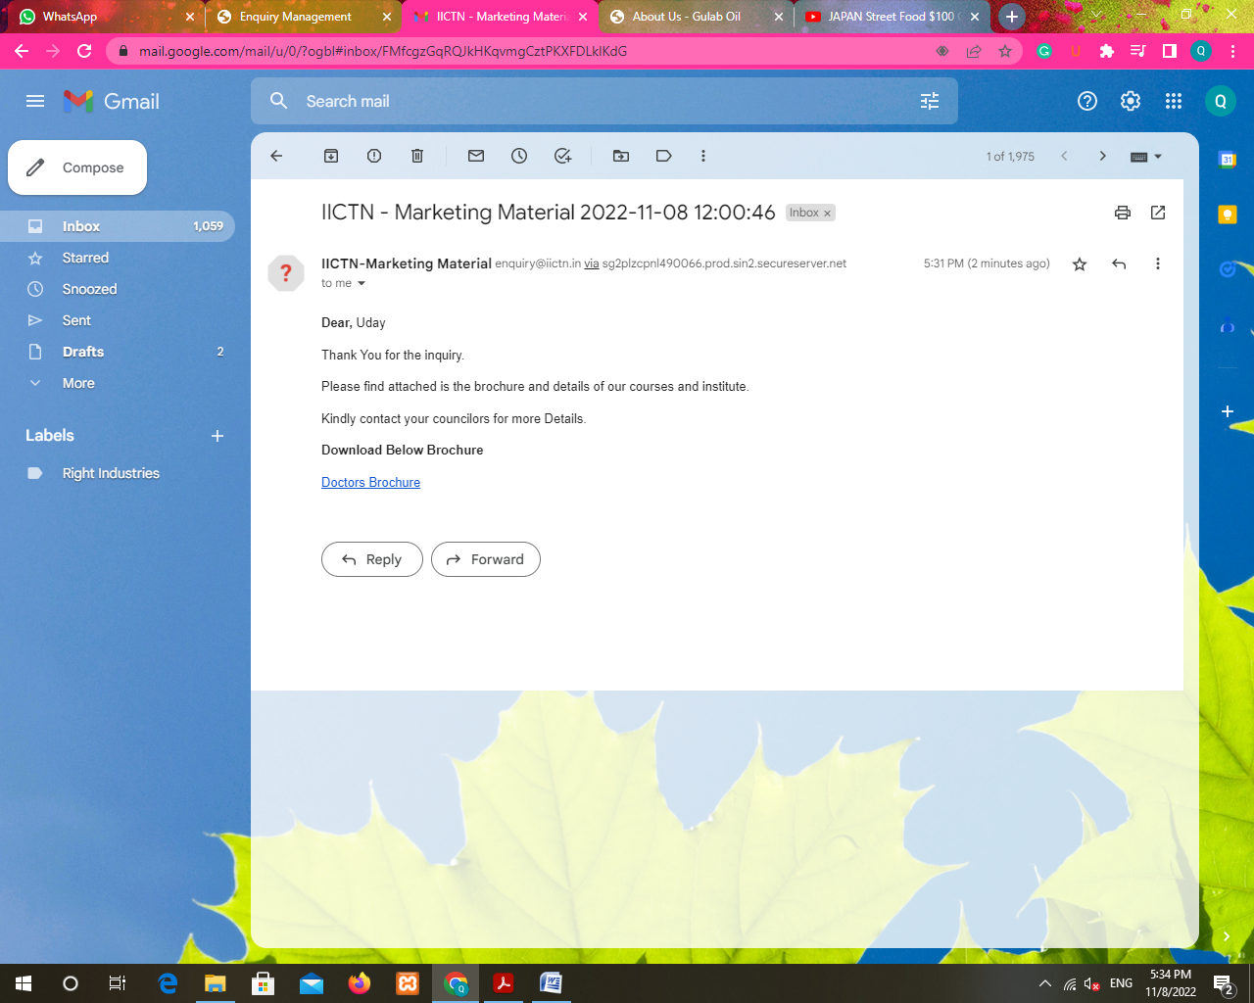

Comma should be after Uday and Details ‘D’ should be small and make email font bigger

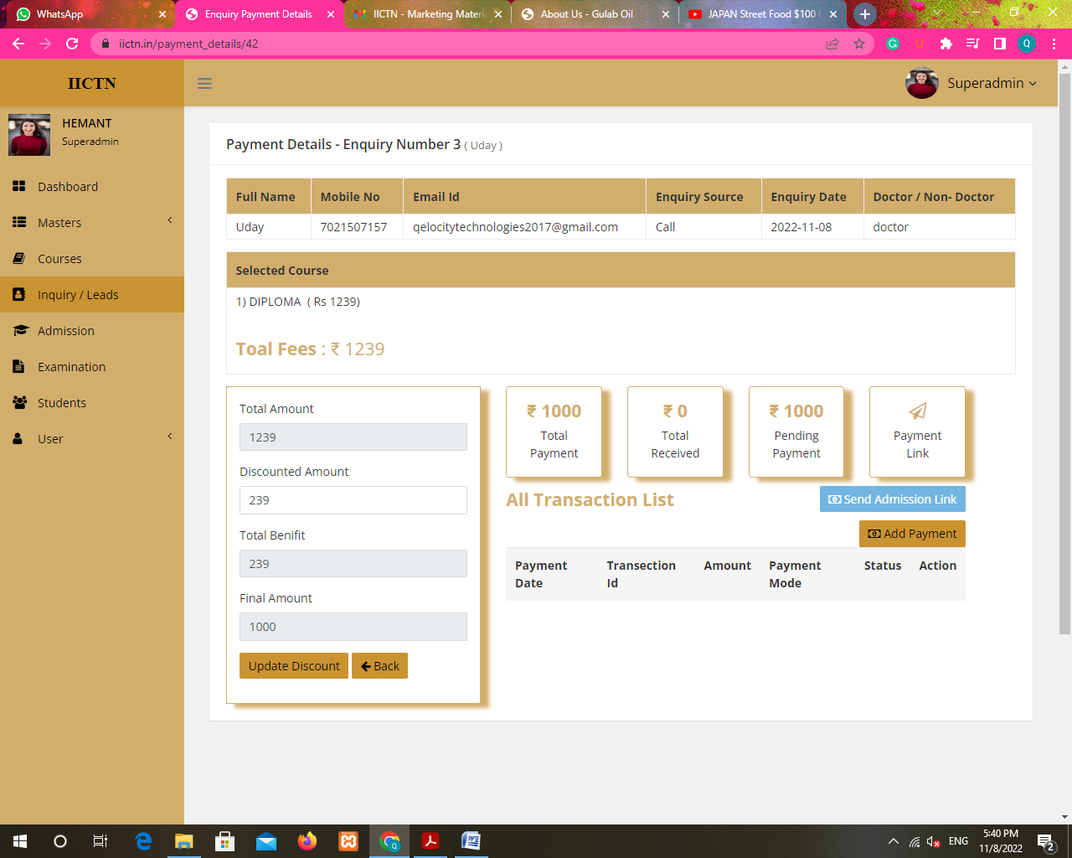

Benifit spelling should be ‘Benefit’ and ‘Sebd Admission Link’ should be ‘Send Payment Link’.

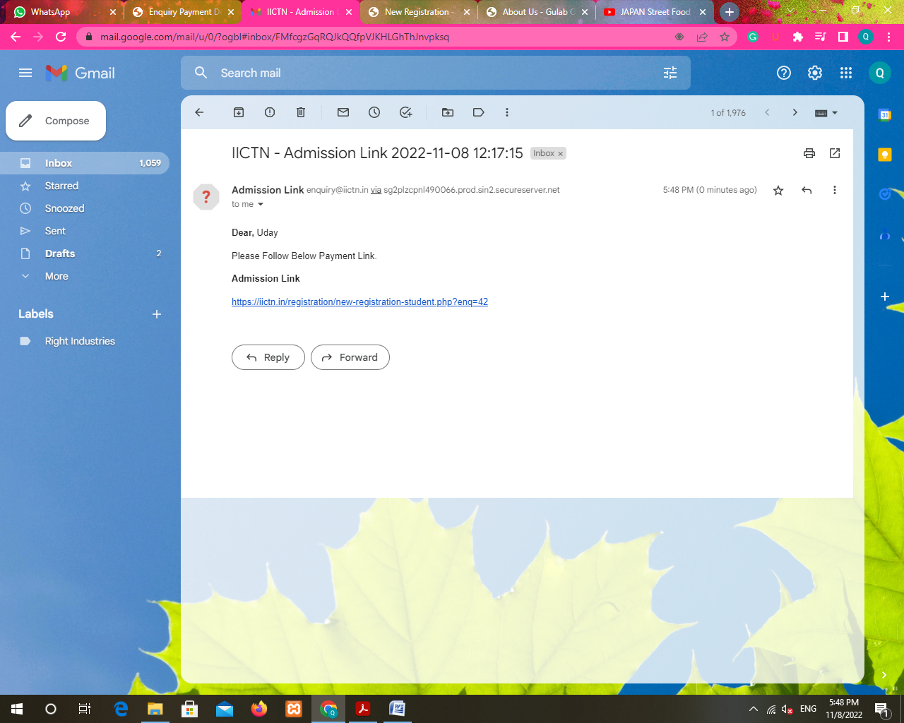

Change Payment Link to ‘Admission Link’

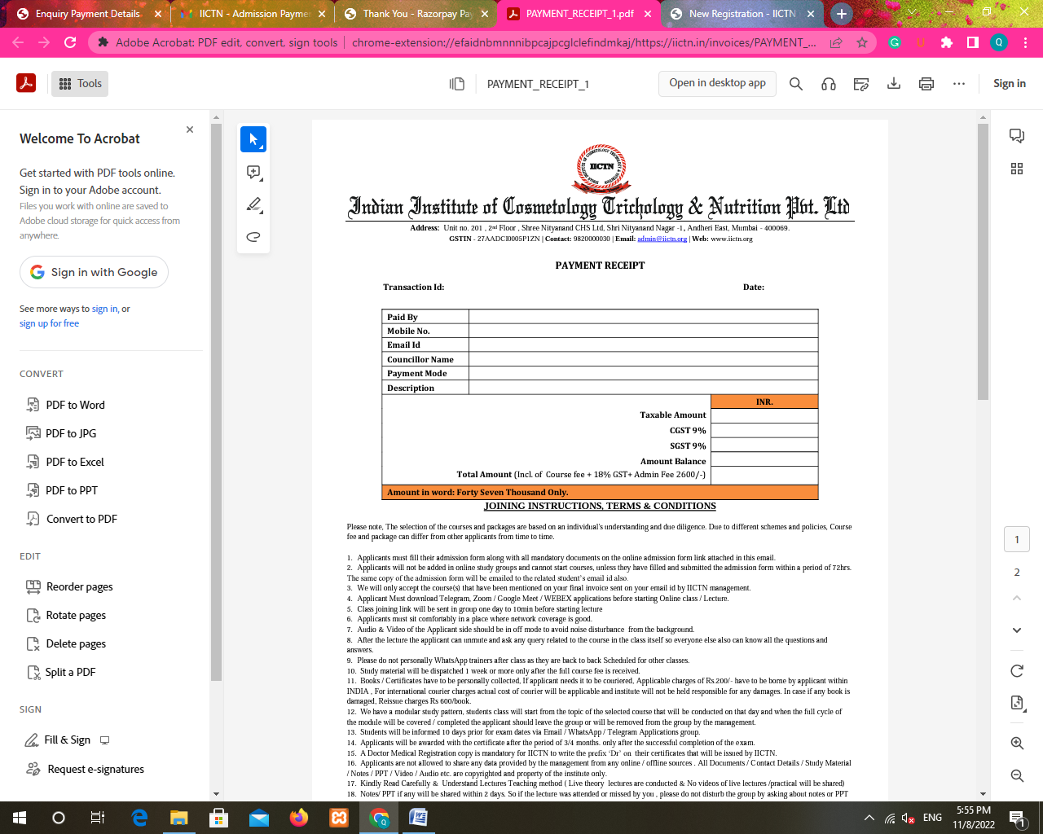

Data is blank and it should beTax Invoice.

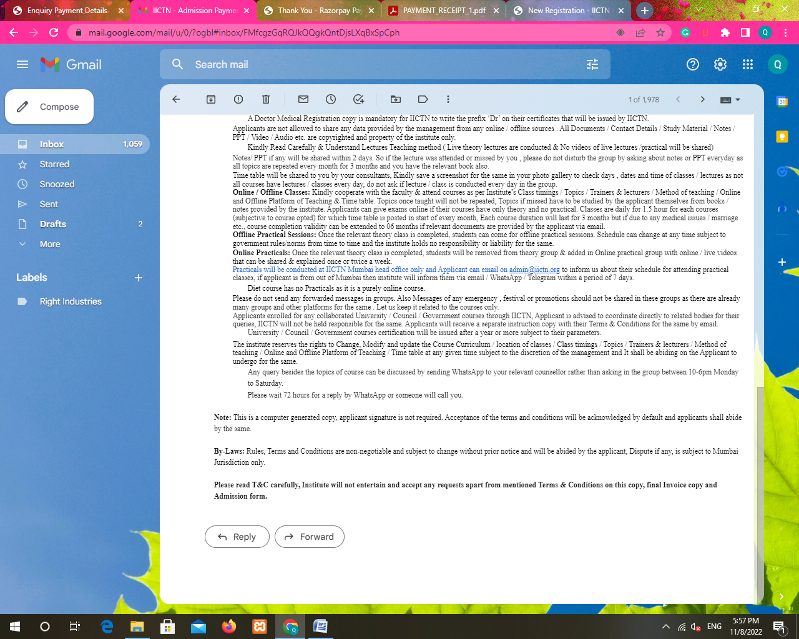

No Tax invoice on email as well

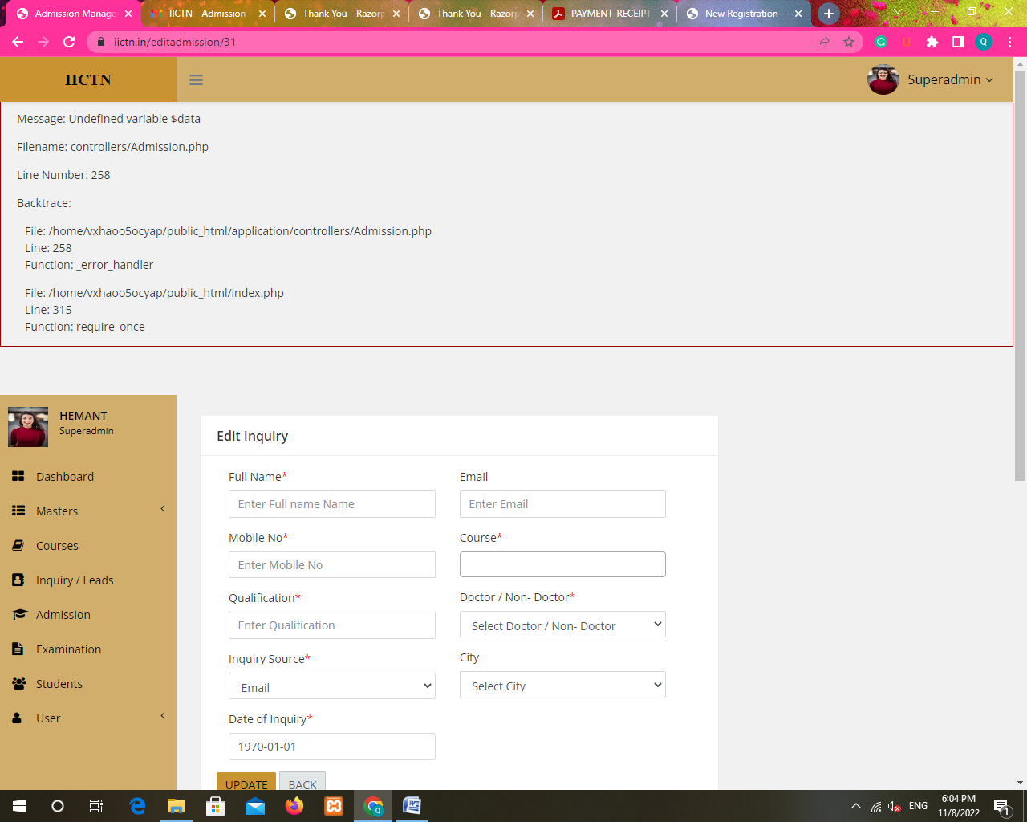

On admission edit error

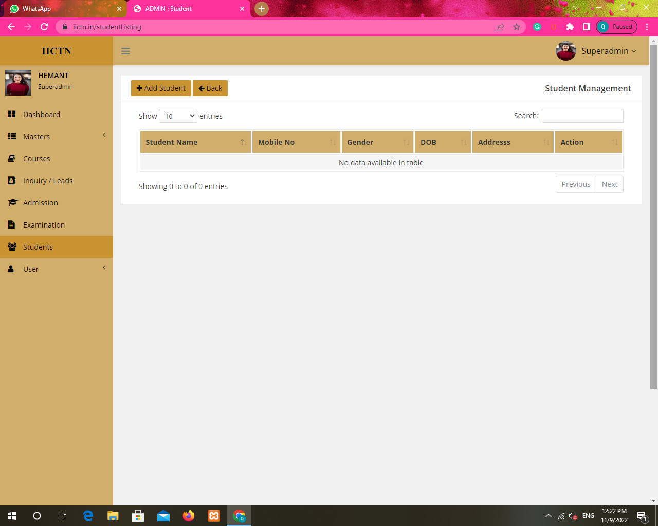

Student disappears after we update the added student in students and when add new student edit the phone no and gender changes automatically

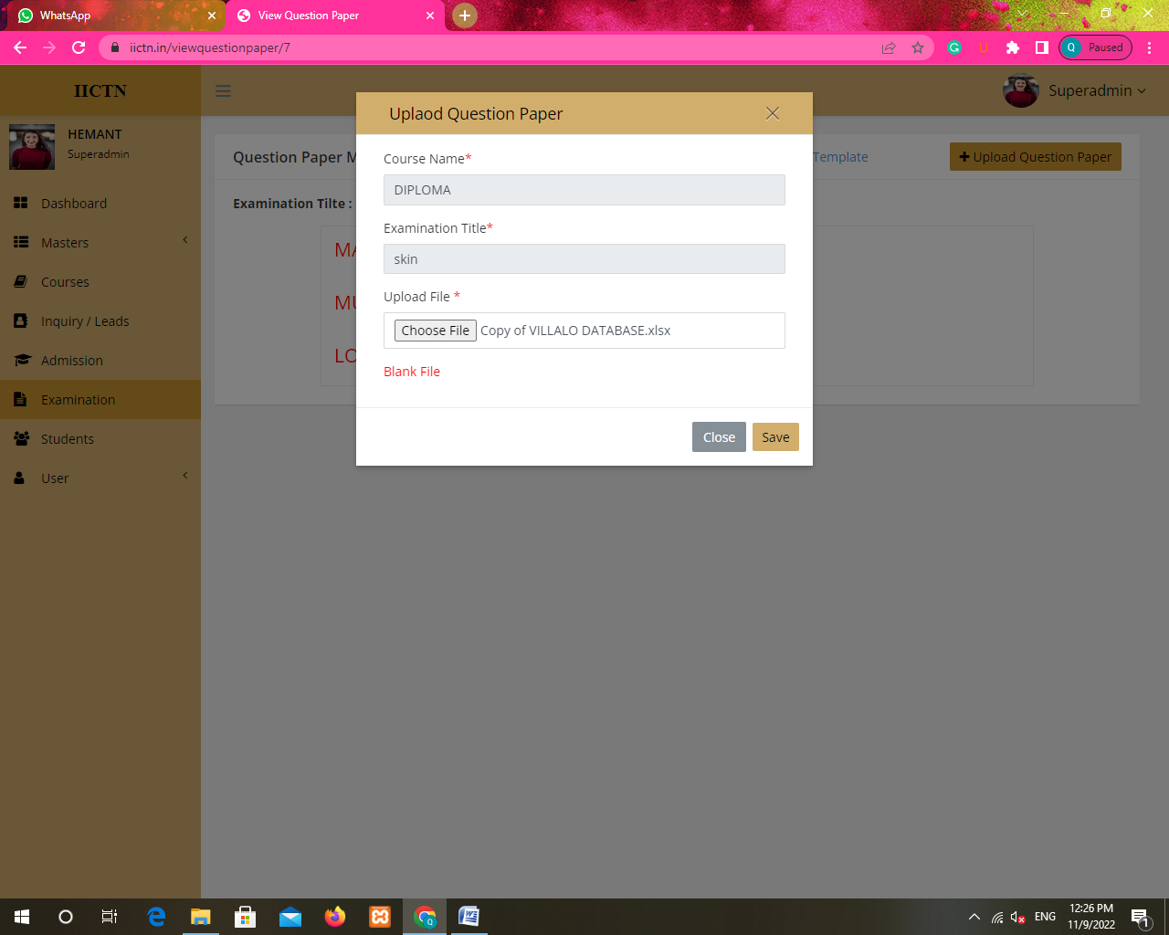

In upload question paper in examination its not accepting file even if it is xlsx

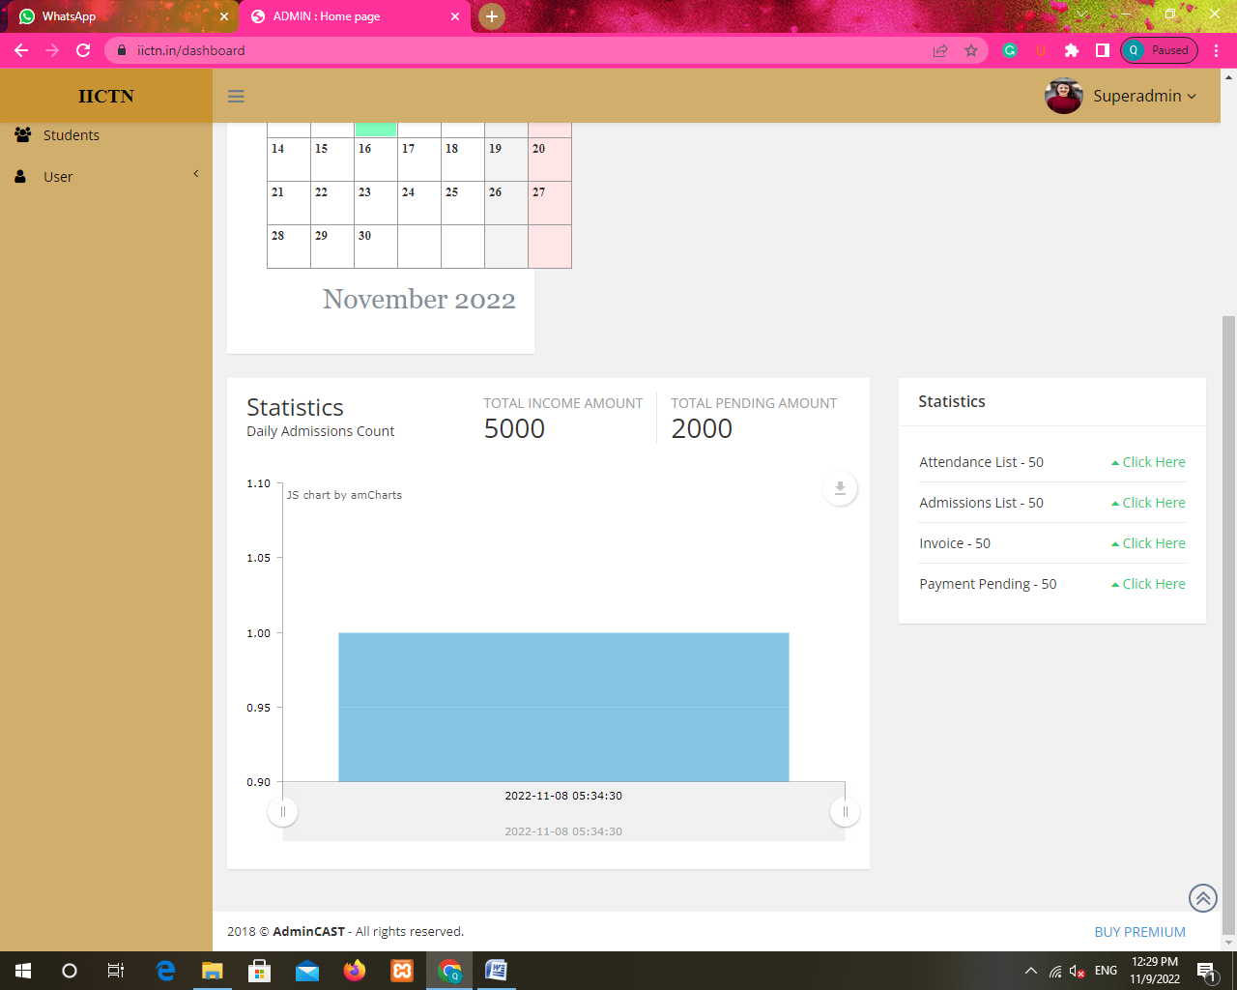

Click here button in dashboard in not clickable

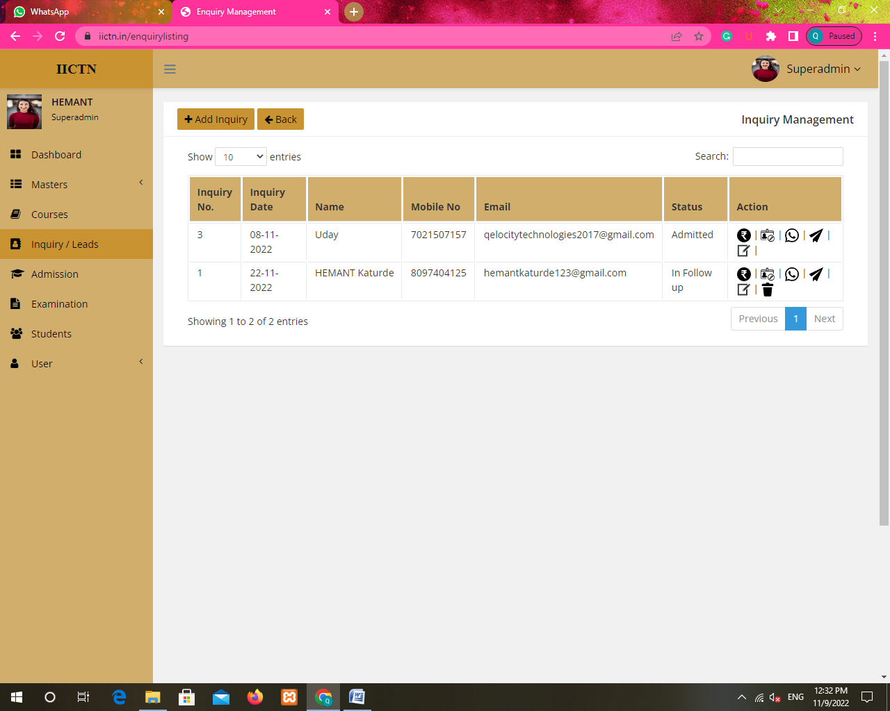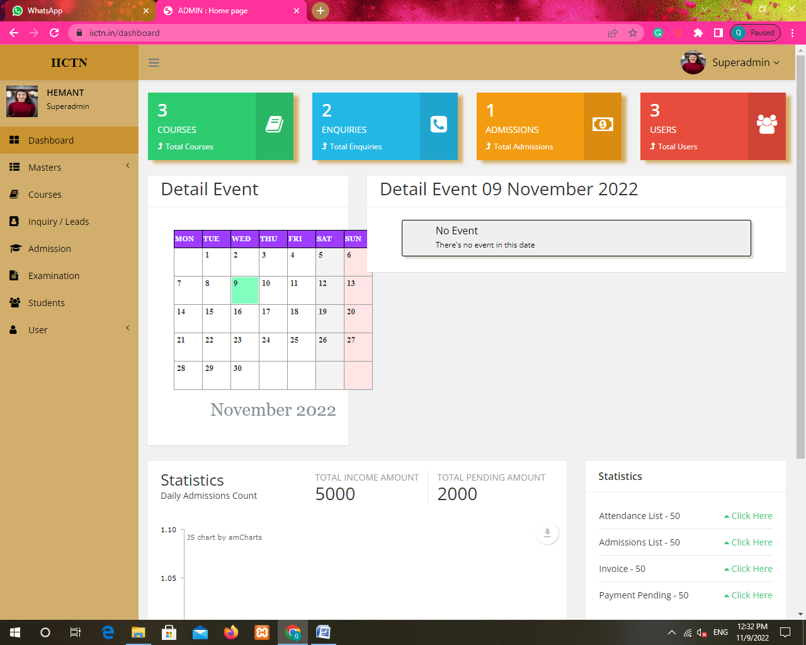

In dashboard total admissions should be 2



When clicked on users on dashboard it takes us to inquiry page instead of USER page